**Patient Tracking and Monitoring Using PIP tags**

**Objective:**

There are three main objectives of our project “Patient Tracking and Monitoring”.

· The first one is to identify a patient’s presence in the room. If the patient is present in the assigned room his presence is recorded else a warning notification is triggered to the management.

· The second objective is to monitor the temperature and the humidity in the patient’s room. Each room in a medical facility has a threshold value. If the temperature or humidity falls below or raises above the threshold value, the message is sent to the management so that necessary actions can be taken.

· The third one monitors the light conditions of a room. Depending on the patient presence in the room, the light is turned on/off. This will reduce the patient’s efforts.

**Progress Report:**

The process was split into two main domains:

1. Hardware dependencies: Setup of the Virtual Box with Linux OS, Configuration of the PIP tag sensors and receivers for Linux OS.
2. Software Dependencies: Installing required libraries for PIP tag receiver and sensors, deciding on programming language for the project.

Below is the status of our ongoing project

|  |  |  |
| --- | --- | --- |
| S.No | Requirement | Status |
| 1 | Set up of Virtual environment with Linux based OS using virtual box | Completed |
| 2 | Set up of the PIP tag sensors and receiver communication | Completed |
| 3 | Node-Mailer module from Node.js | Completed |
| 4 | JavaScript coding for Email Notification using  ->RfId sensor  ->Light sensor  ->Humidity Sensor  ->temperature sensor | In progress |

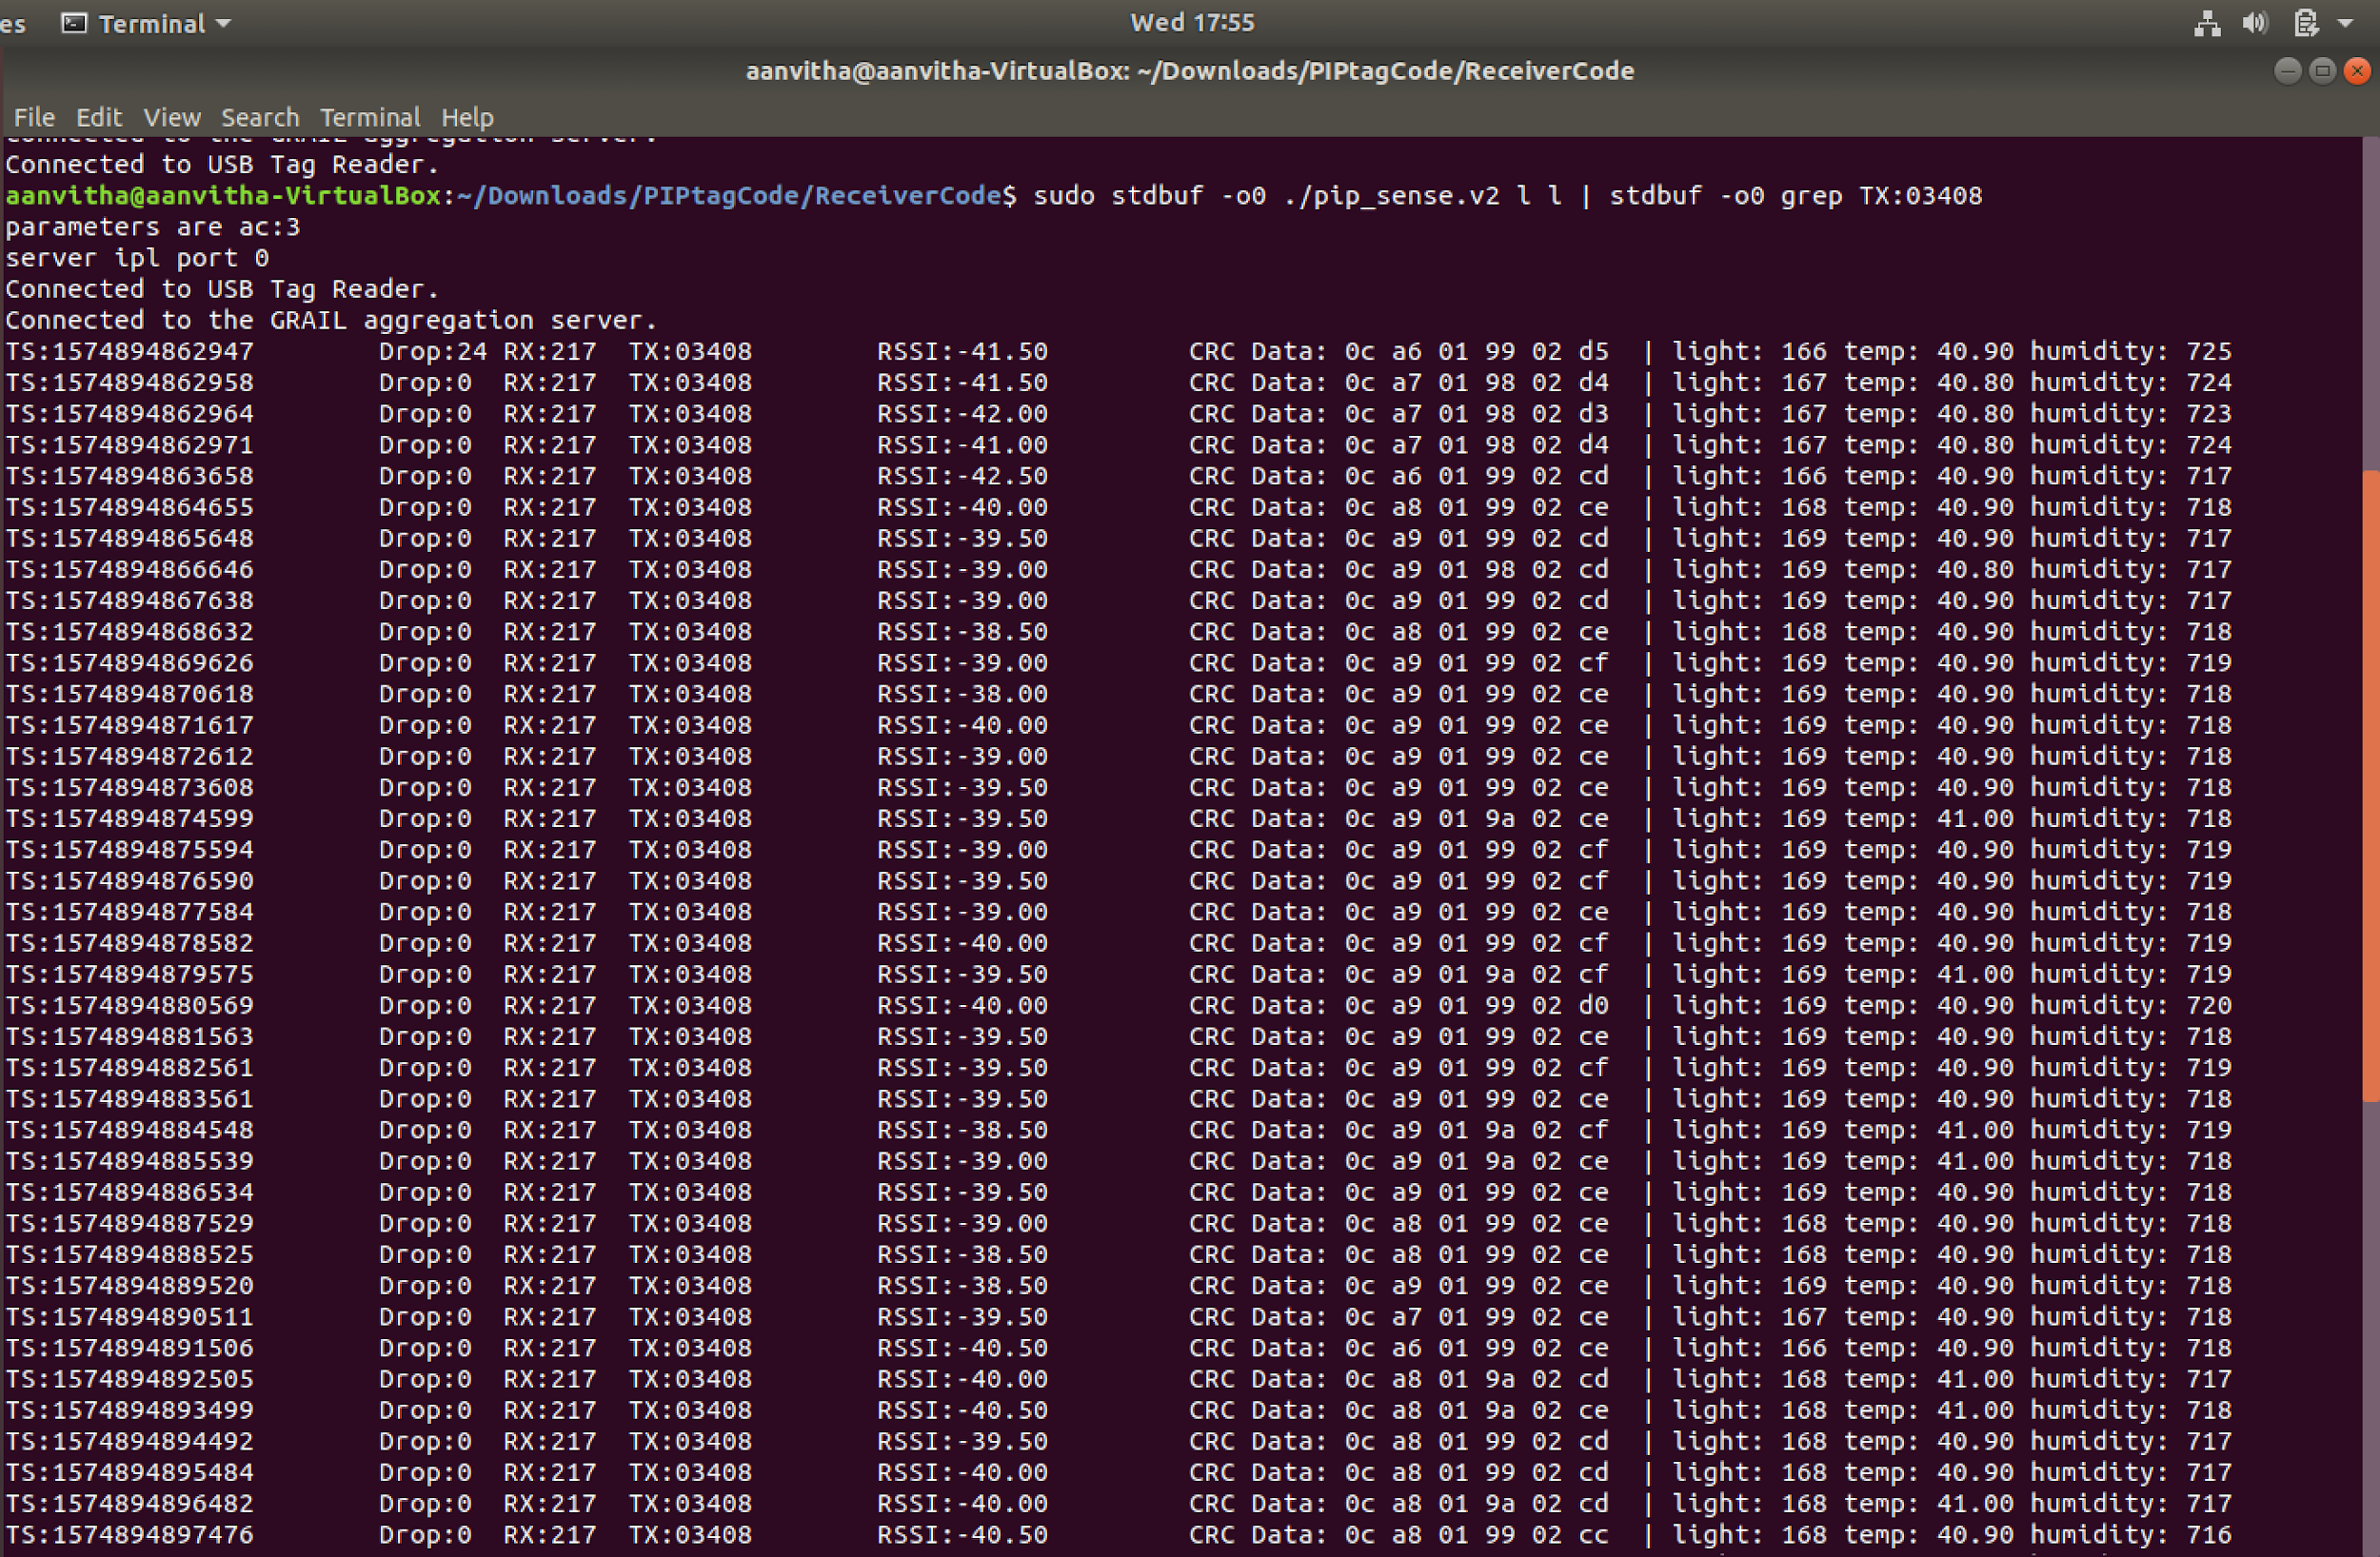

**Team Members:**

1)Anvitha Selva Kumar- [as3051@scarletmail.rutgers.edu](mailto:as3051@scarletmail.rutgers.edu)

2)Krutant Patel- [khp52@scarletmail.rutgers.edu](mailto:khp52@scarletmail.rutgers.edu)

3)Priyanka Rajan- [pr417@scarletmail.rutgers.edu](mailto:pr417@scarletmail.rutgers.edu)

4)Sanyam Jain – [sj770@scarletmail.rutgers.edu](mailto:sj770@scarletmail.rutgers.edu)